# Sleep-2-Learn: Learning Analysis (extended)

## Experiment I – Interplay of ML Algorithms and Resampling Techniques

##### AUC

##### Kappa

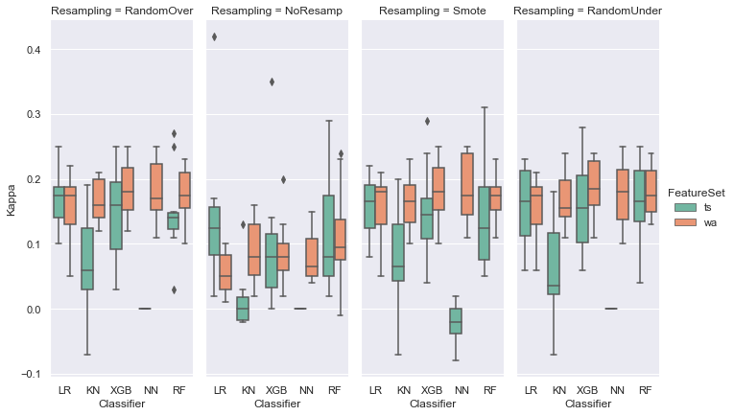

##### MCC

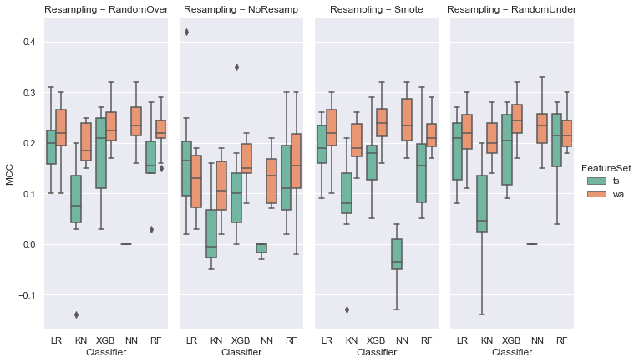

##### Light Acc

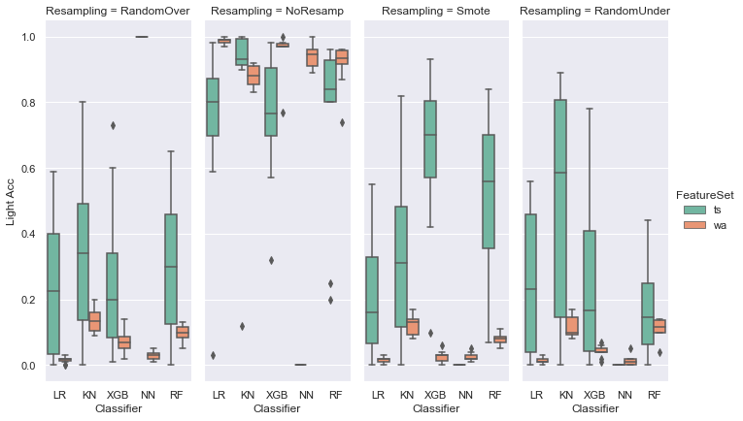

##### Deep Acc

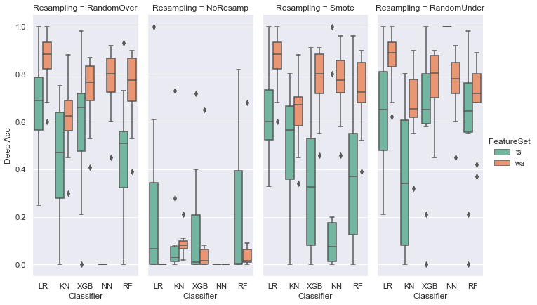

##### REM Acc

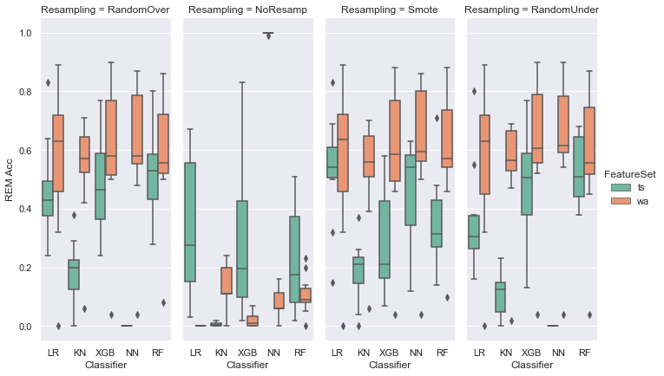

##### Wake Acc

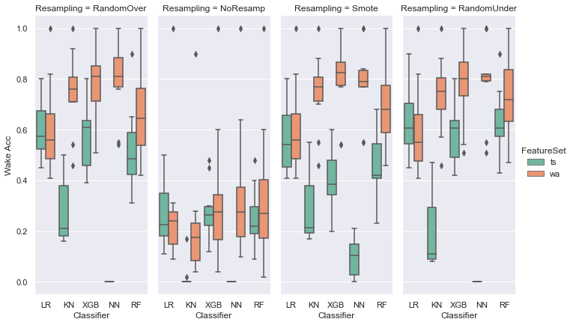

## Experiment II – Changes in Epoch size and Resampling with XGBoost algorithm

##### AUC

##### Kappa

##### MCC

##### Light Acc

##### Deep Acc

##### REM Acc

##### Wake Acc

## 